

**Children’s Residential**

**Ennerdale Autism Program**

**Location: Dufferin & Eglinton**

 

**Eligibility**

The Child/youth must have a primary diagnosis of an Autism Spectrum Disorder and be between the ages of

2-17.

Ennerdale is a 3 bedroom respite program with a 1:2 staff/child ratio. All bookings are done by the supervisor of the program. Where possible your child will be matched with other children of familiar age and ability.

Children have the option of spending the night or just a few hours. All meals are prepared for the children. Parents have the option of booking a single or shared room. Activities include toys, arts and craft, games, movies and outings.

Ennerdale staff have training and experience in supporting the unique social emotional and communication needs of children with autism.

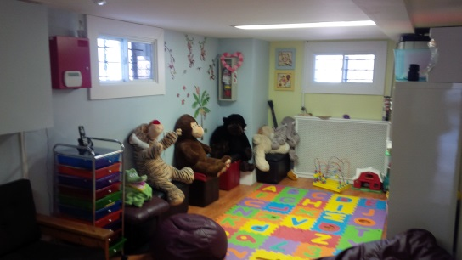

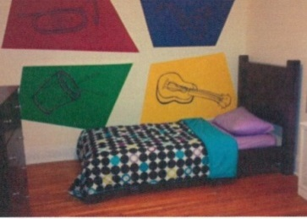

To arrange a tour, contact: 647.729.0476

**Lawson Children's Respite**

**Location: Ellesmere & McCowan**

**[](https://www.google.ca/imgres?imgurl=https://upload.wikimedia.org/wikipedia/commons/0/0c/Wheelchair_symbol.svg&imgrefurl=https://commons.wikimedia.org/wiki/File:Wheelchair_symbol.svg&h=551&w=483&tbnid=_c6D1uBb7y1wbM:&docid=RJOPt0pSWU_ZOM&ei=kFPPVsyhHYz0-QGJyKfIBw&tbm=isch&ved=0ahUKEwjMqd3m0JPLAhUMej4KHQnkCXkQMwggKAAwAA)**

**Eligibility**

The child/youth must have a primary diagnosis of having an intellectual disability or Autism Spectrum Disorder and be between the ages of 2-17. The ratio is 3 children to one staff.

Children have the option of spending the night or just a few hours. Activities include; sensory room, outdoor play­ ground, games, arts, & crafts, movies, computers, personal internet access and all outings are planned to meet the needs of the individual.

Lawson Children’s Respite Program Consists of 3 apartments.

Discovery Cove 2 – 8 years old

Treasure Island 9 – 13 years old

Adventure Planet 14 – 17 years old

There are staff 24 hours a day, with an overnight awake staff in each apartment. Children will receive interactive support from Lawson’s well trained staff. All meals and snacks are provided, and any dietary restrictions are accommodated.

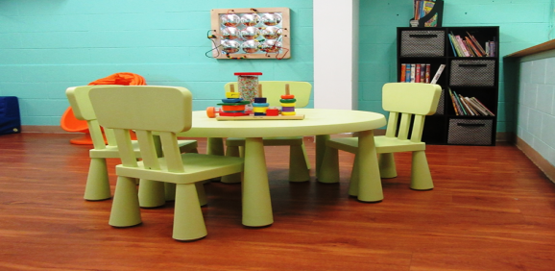

Lawson Children’s Respite program supports children of all abilities, families and caregivers will receive the attention and support to meet the needs of their child during their short break.

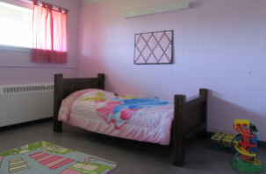

To arrange a tour, contact: 647.729.1639