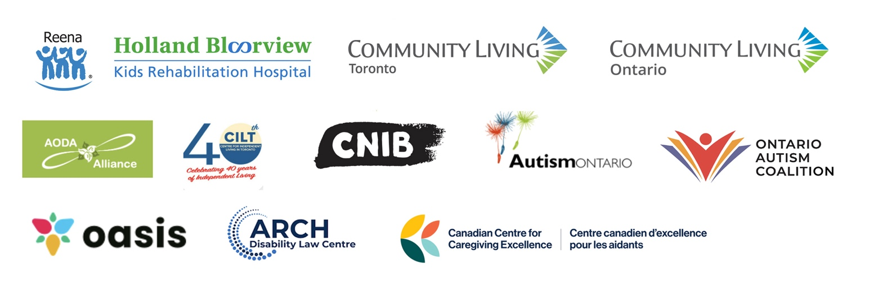

**Coalition of disability organizations calls on parties to make Ontarians with disabilities a priority in Ontario election**

*Twelve organizations host election debate with more than 500 attendees*

**TORONTO, ON (February 20, 2025)** – On February 19, 2025, a coalition made up of a broad cross-section of disability organizations hosted an Ontario election debate with a record-breaking audience, focused on issues important to 2.9 million Ontarians with disabilities. Each sponsoring community organization is non-partisan and committed to working with elected provincial leaders to advance work to make Ontario accessible and inclusive for people with all kinds of disabilities.

The coalition includes the [AODA Alliance](https://www.aodaalliance.org/), [Autism Ontario](https://www.autismontario.com/), [Reena](https://reena.org/), [Community Living Toronto](https://cltoronto.ca/), [Community Living Ontario](https://communitylivingontario.ca/), [Canadian Centre for Caregiving Excellence](https://canadiancaregiving.org/), the [Ontario Autism Coalition](https://ontarioautismcoalition.com/), [OASIS](https://oasisonline.ca/), the [Centre for Independent Living in Toronto](https://cilt.ca/), the [ARCH Disability Law Centre](https://archdisabilitylaw.ca/), [CNIB,](https://www.cnib.ca/en?region=on) and [Holland Bloorview Kids Rehabilitation Hospital](https://hollandbloorview.ca/). The debate was moderated by Isaac Callan, digital broadcast journalist, Global News.

The forum, which was attended by more than 500 people both virtually and in person at [Holland Bloorview Kids Rehabilitation Hospital](https://hollandbloorview.ca/) in Toronto, was an important opportunity for the community to raise issues, ask timely questions and have their voices heard. More than 150 questions were pre-submitted by registrants demonstrating tremendous interest in topics ranging from social assistance and accessible housing to inclusive schools and legislation and human rights.

All four major provincial parties were invited. Representatives from the Ontario Liberal Party, Ontario NDP and Green Party of Ontario attended. Each had the opportunity to describe what their party will do for Ontarians with disabilities if elected. The Ontario Conservatives did not send a representative, although repeatedly invited to do so.

“More than 2.9 million Ontarians now have a disability and all other Ontarians are bound to get one as they age – and far too many are being left behind,” says David Lepofsky, disability advocate and chair of the [AODA Alliance](http://www.aodaalliance.org). “This election comes at a critical time for Ontarians with disabilities, because Ontario is still not accessible, contrary to the legislated 2025 deadline, which the Accessibility for Ontarians with Disabilities Act (AODA) imposed. It takes courage for a candidate to put their record on the line and take voters’ questions face-to-face.”

Quotes from party representatives at the debate:

**Marjorie Knight – Ontario NDP**

“It has to be more than just doubling social assistance rates. It has become the Hunger Games amongst non-profits and community groups where everybody's fighting over the same funding, which gets increasingly smaller and smaller. Adequate, stable funding needs to be done and it needs to be intentionally done. [Affordable] housing is the same problem. People are waiting 40, 10, 20, 15 years [for housing]. We have to get back into the business of building [affordable homes].”

**Kathryn McGarry – Ontario Liberal Party**

“We need to ensure that our kids can learn in barrier-free spaces. We need the supports for [the] 38,000 kids languishing on the wait list for [autism] assessment. The Liberals are committed to ensuring that…we have timely access to assessments for families with autistic children.”

**Ignacio Mongrell – Green Party of Ontario**

“I think the Green Party has shown that it believes in economic fairness [and] that no one should be left behind, especially the groups that are more vulnerable and have been underrepresented in the past. That’s why, as a member of the Green Party, I’m here taking action. I’m here because I care about what people with disabilities are facing…and I want to show that they have the support of the Green Party.”

Access a recording on [YouTube](https://www.youtube.com/watch?v=IEqhe2Akems) of the full debate.

We encourage all Ontarians to raise disability issues with their provincial candidates in the lead up to the election and to vote on February 27.

-30-

**For media inquiries, please contact:**

Teresa Kruze

[tkruze@rogers.com](mailto:tkruze@rogers.com)

David Lepofsky [aodafeedback@gmail.com](mailto:aodafeedback@gmail.com)

Erin Pooley  
[epooley@hollandbloorview.ca](mailto:epooley@hollandbloorview.ca)